

VITYARTHI PROJECT 2025-26
BMI CALCULATOR
_____________________________
COURSE 1021: INTRODUCTION TO PROBLEM SOLVING AND PROGRAMMING
SLOT: A11 A12 A13
FACULTY NAME: PAVITHRA
STUDENT NAME: PANKHUDHI GOSWAMY
REGISTRATION NO.: 25BCE10145
STUDENT COURSE: CSE CORE
INTRODUCTION

BMI is a measurement of a person's leanness or corpulence based on their height and weight, and is intended to quantify tissue mass.
It is widely used as a general indicator of whether a person has a healthy body weight for their height.
Specifically, the value obtained from the calculation of BMI is used to categorize whether a person is underweight, normal weight, overweight, or obese depending on what range the value falls between.
These ranges of BMI vary based on factors such as region and age, and are sometimes further divided into subcategories such as severely underweight or very severely obese.
Being overweight or underweight can have significant health effects, so while BMI is an imperfect measure of healthy body weight, it is a useful indicator of whether any additional testing or action is required.
Refer to the table below to see the different categories based on BMI that are used by the calculator.

PROBLEM STATEMENT

Many individuals struggle to understand whether their body weight is suitable for their height. There is a need for a simple, easy-to-use tool that quickly calculates BMI and categories the user’s health status.

This project provides an efficient solution using a python program.

FUNCTIONAL REQUIREMENTS
The BMI calculator must:
- Accept user input for height(in meters/cm) and weight ( in kilograms).
- Calculate BMI using the formula:
BMI= weight(kg)/ height²(m²).
- Display the calculated BMI.
- Categorize the BMI into:
- Underweight
- Normal weight
- Overweight
- Obese
- Handle invalid inputs(negative or zero values).

NON- FUNCTIONAL REQUIREMENTS
- Usability:- interface must be simple and easy to understand.
- Performance:- BMI should be calculated instantly.
- Reliability:- should produce accurate results every time.
- Portability:- the script should run on any system with python installed.
- Scalability:- Can be extended to include more features.
SYSTEM ARCHITECTURE

A simple 3-layer architecture:

- Input layer

- Takes user inputs(height & weight).

- Processing layer

- Performs BMI calculation.
- Applies conditional logic to determine category.

- Output layer

- Displays BMI value and category to the user.

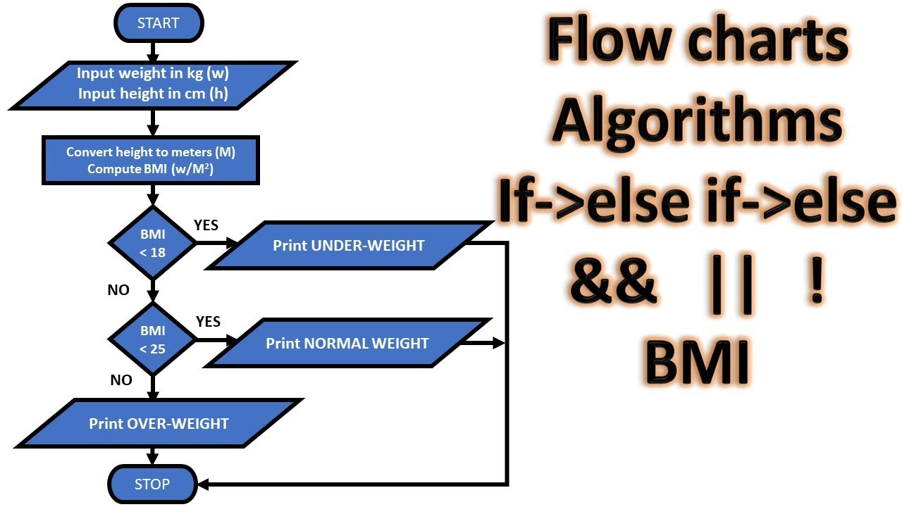
FLOWCHART
CODE

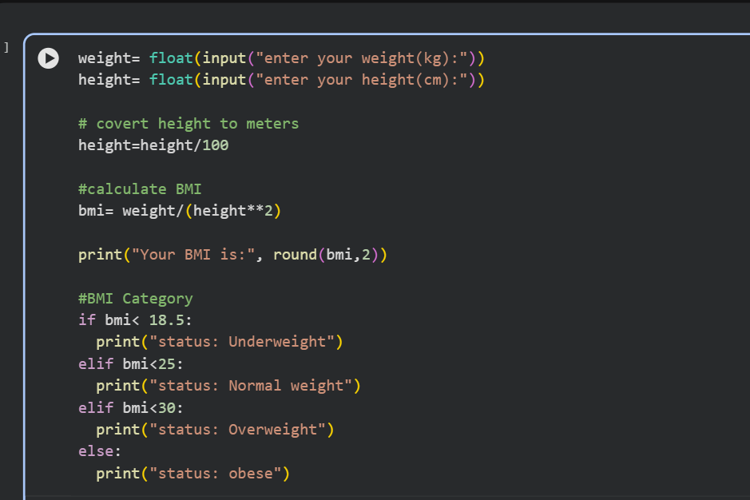

OUTPUT

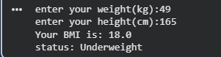

TESTING APPROACH
Testing was done using:
- Normal values:- Valid height and weight inputs.
- Boundary values:- Extremely low or high values.
- Invalid inputs:-
- Zero
- Negative values
- Non- numeric inputs
All results matched expected outputs.

CHALLENGES FACED
- Handling invalid inputs properly.
- Ensuring the BMI classification matches the standard WHO chart.
- Making the program more user-friendly.

LEARNINGS & KEY TAKEAWAYS

- Learned how to handle user inputs in python.
- Understood conditional logic for classification.
- Practiced basic software documentation and design diagrams.
FUTURE ENHANCEMENTS
- Add GUI using Tkinter or web version using Flask.
- Store history in a database.
- Provide diet or fitness suggestions based on BMI.
- Add support for multiple units (feet, inches, pounds).

REFERENCES
- WHO BMI classification standards.
- Python officials Documentation.
- Online tutorials ( GeeksforGeeks, W3Schools).
- VITyarthi notes.

